**SQL exercises**

1. Write a SQL statement to create a simple table countries including columns country_id,country_name and region_id.

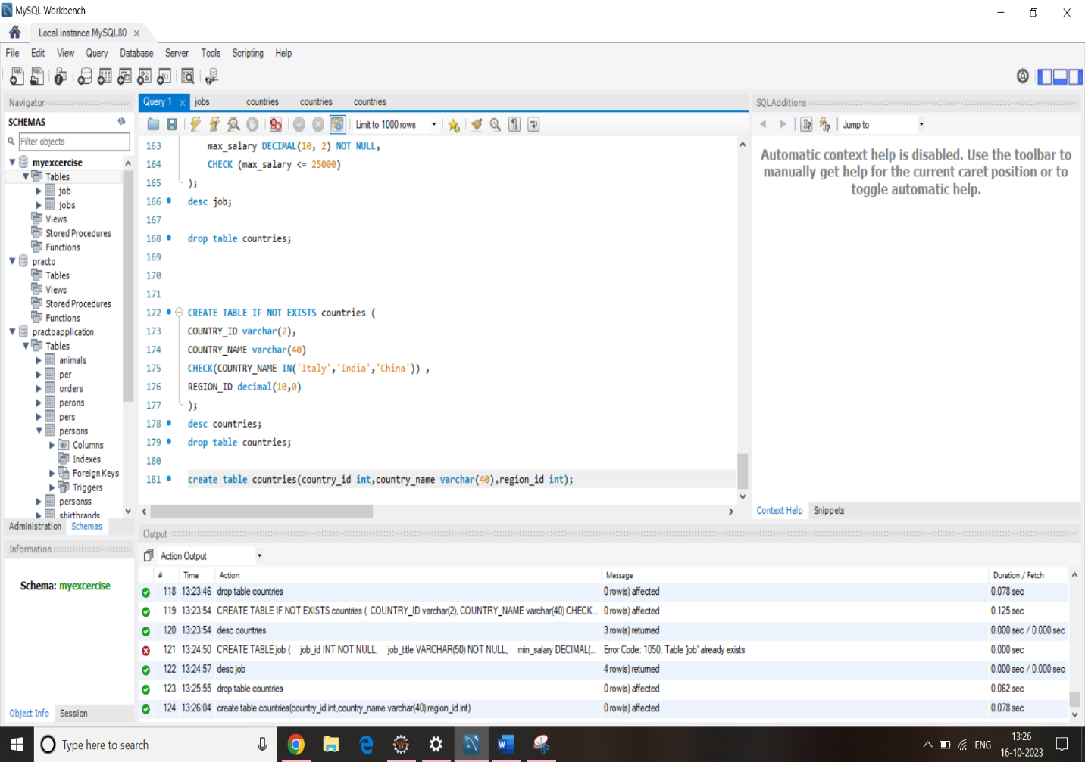

1. 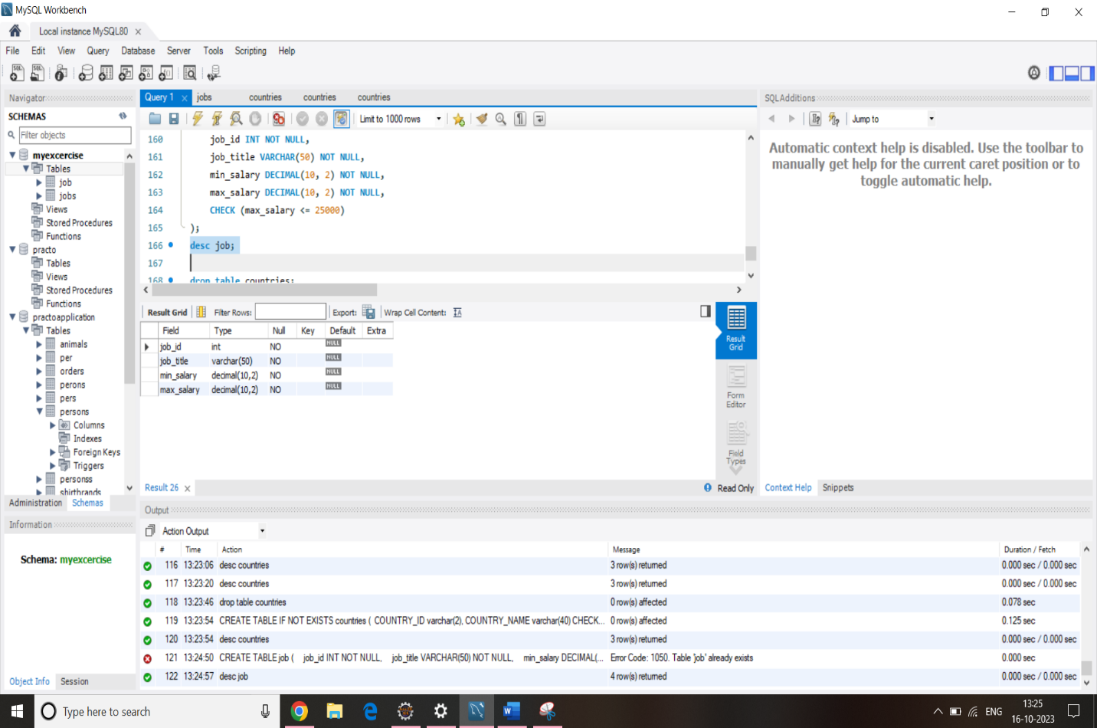Write a SQL statement to create a table named jobs including columns job_id, job_title, min_salary, max_salary and check whether the max_salary amount exceeding the upper limit 25000.
2. Write a SQL statement to create a table named countries including columns country_id, country_name and region_id and make sure that no countries except Italy, India and China will be entered in the table.

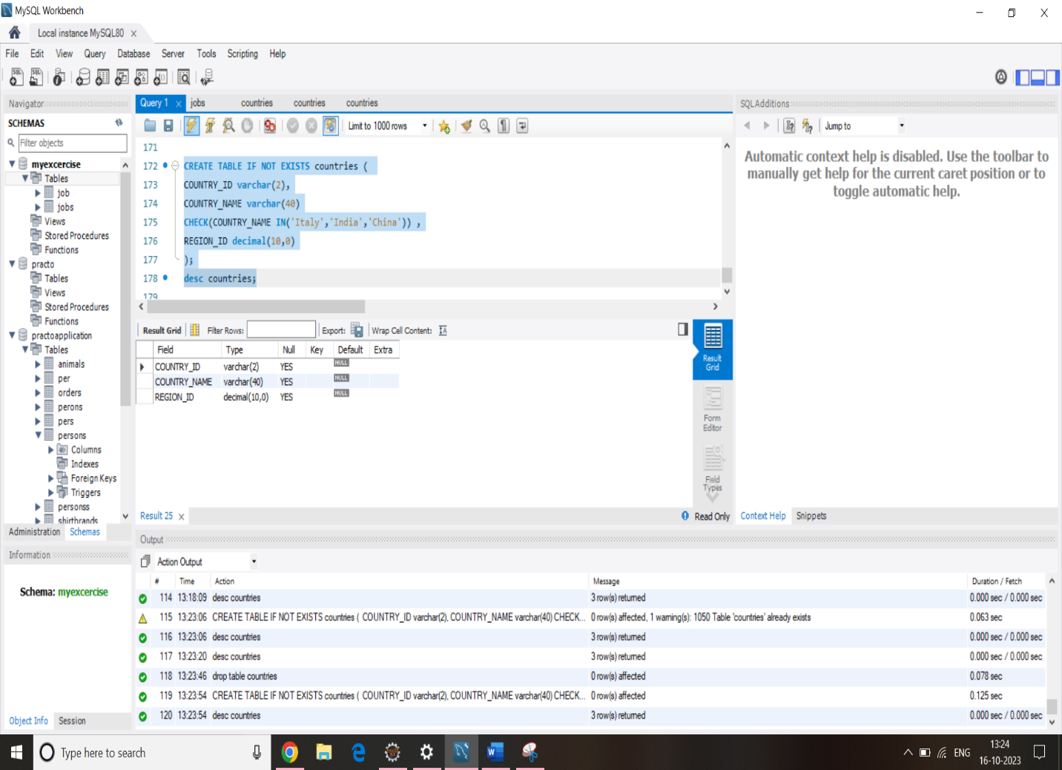

1. Write a SQL statement to create a table named countries including columns country_id,country_name and region_id and make sure that no duplicate data against column country_id will be allowed at the time of insertion.

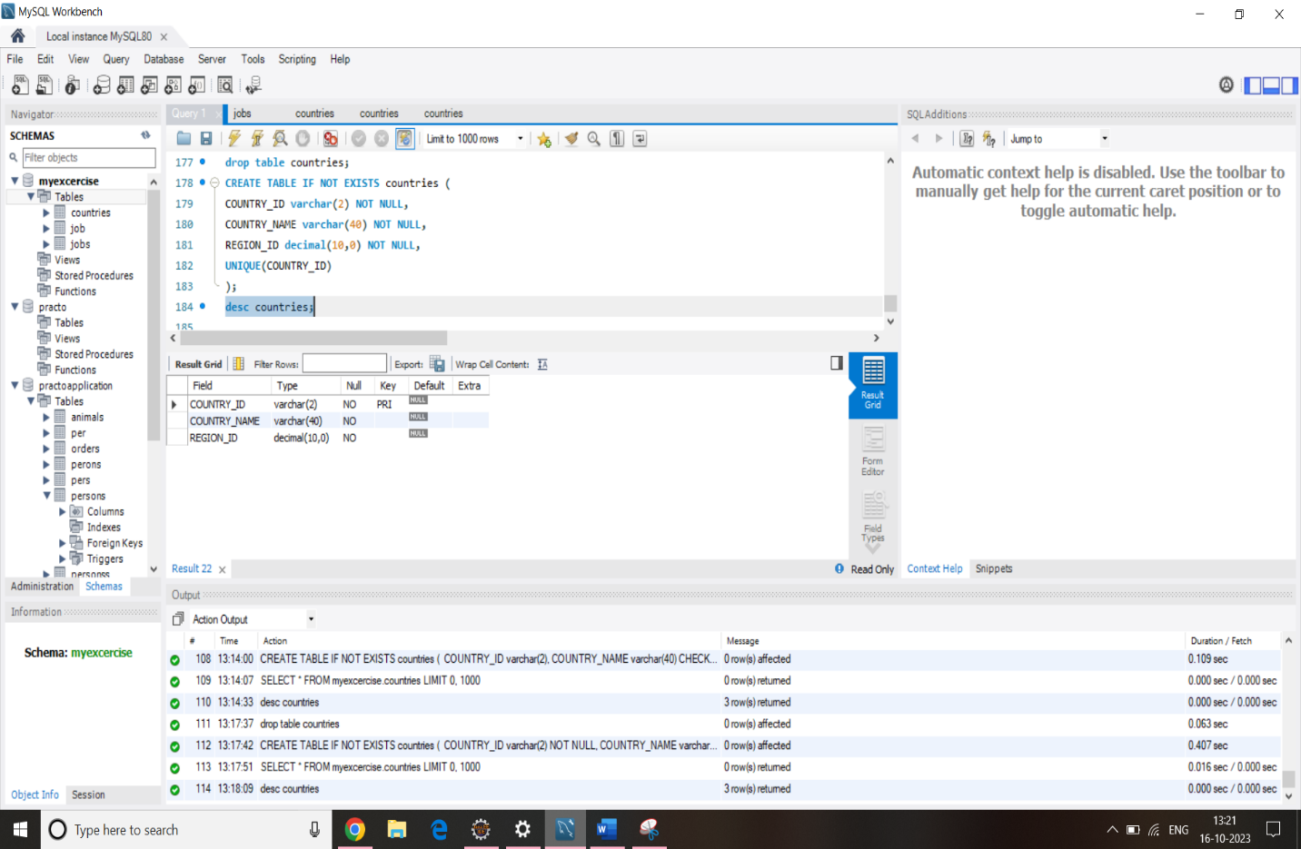

1. Write a SQL statement to create a table named jobs including columns job_id, job_title, min_salary and max_salary, and make sure that, the default value for job_title is blank and min_salary is 8000 and max_salary is NULL will be entered automatically at the time of insertion if no value assigned for the specified columns.

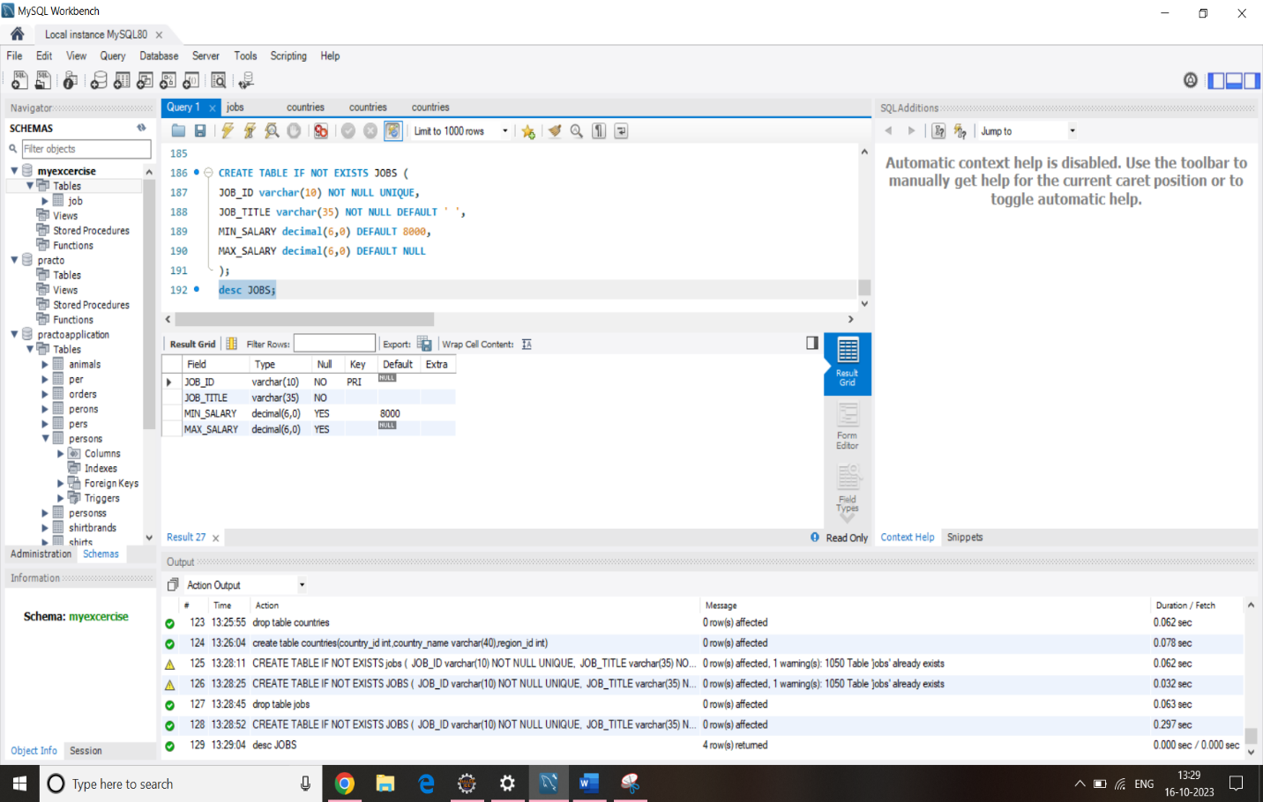

1. Write a SQL statement to create a table named countries including columns country_id, country_name and region_id and make sure that the country_id column will be a key field which will not contain any duplicate data at the time of insertion.

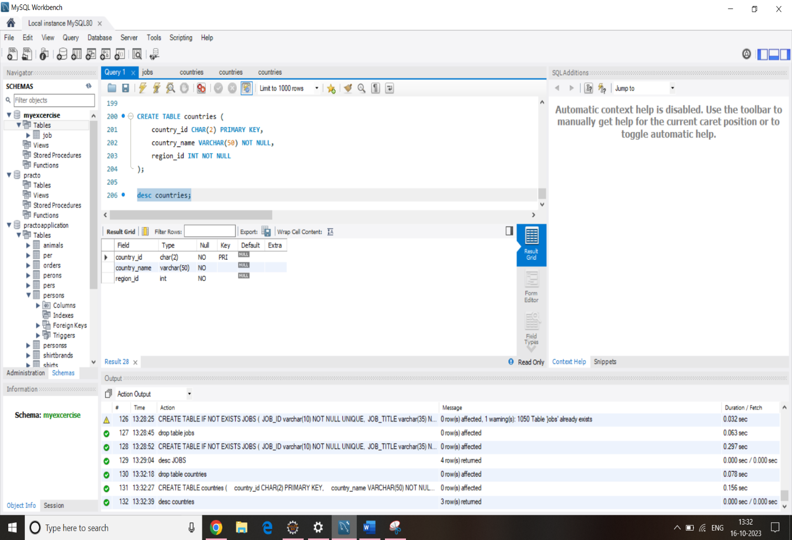

1. 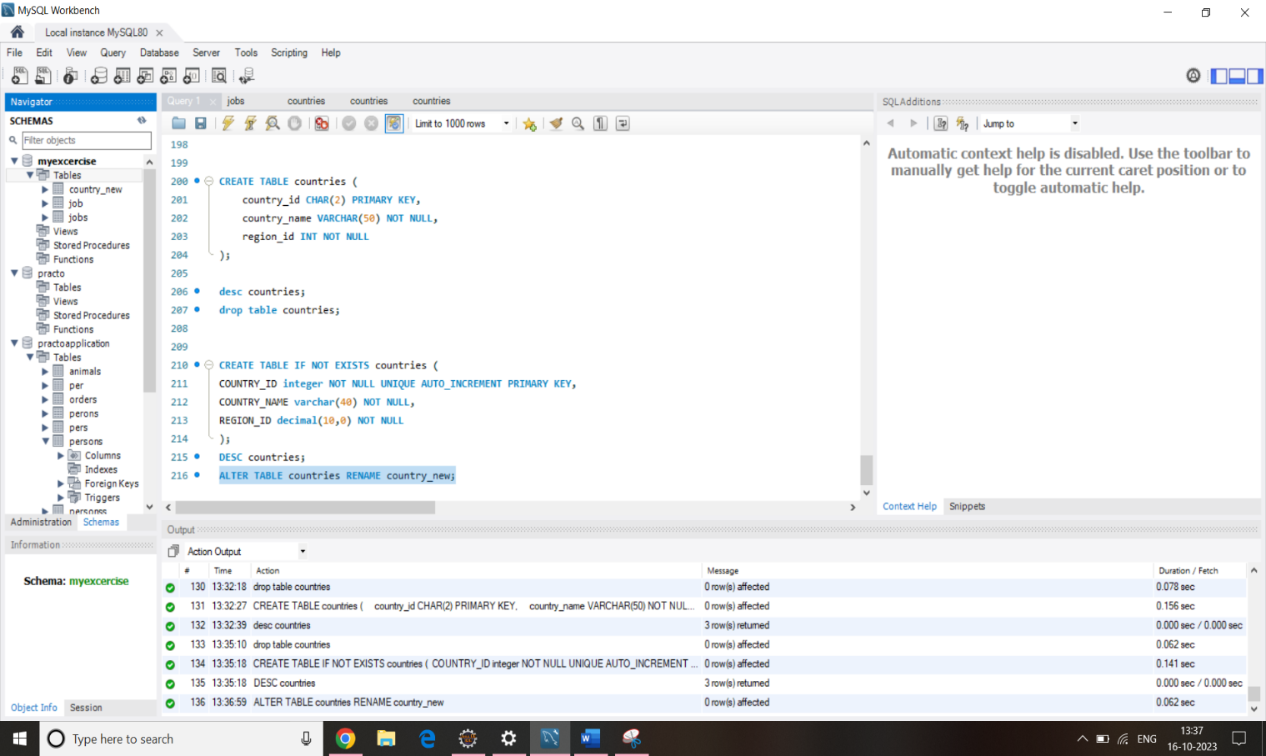Write a SQL statement to rename the table countries to country_new.
2. Write a SQL statement to add a columns ID as the first column of the table locations.

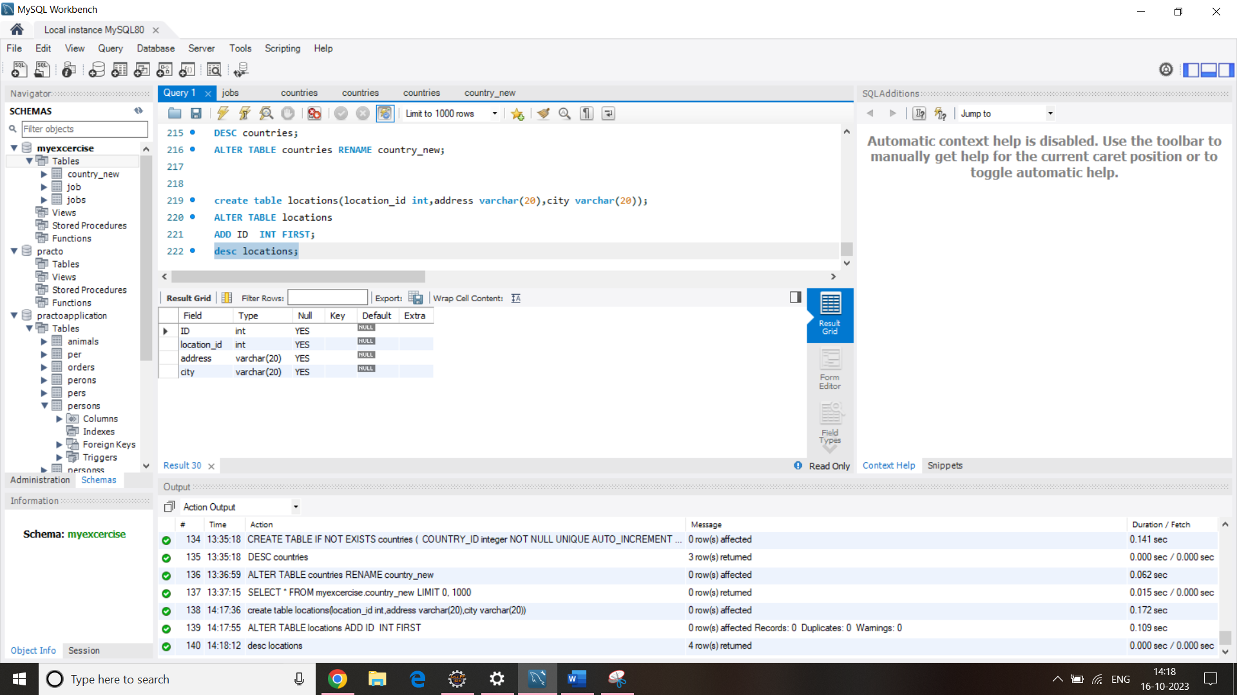

1. Write a SQL statement to change the email column of employees table with 'not available' for all employees.

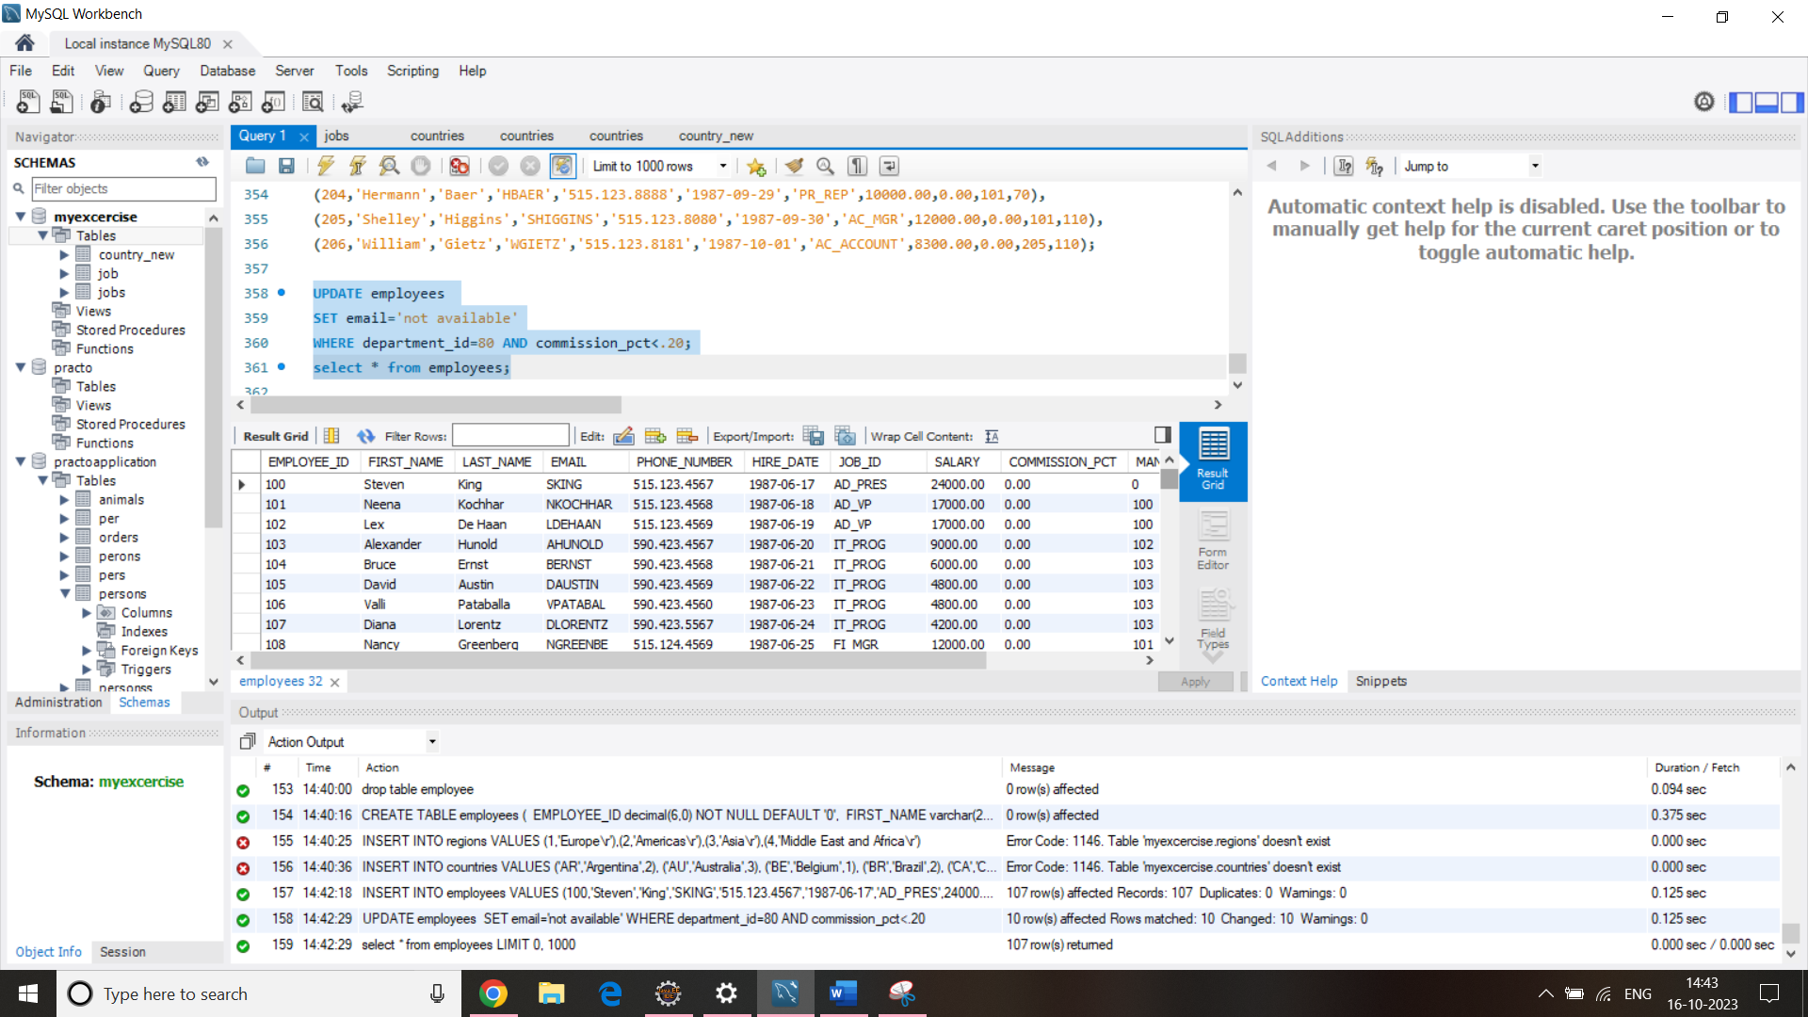

1. Write a SQL statement to change the email column of employees table with 'not available' for those employees whose JOB_ID is ‘FI_ACCOUNT’.

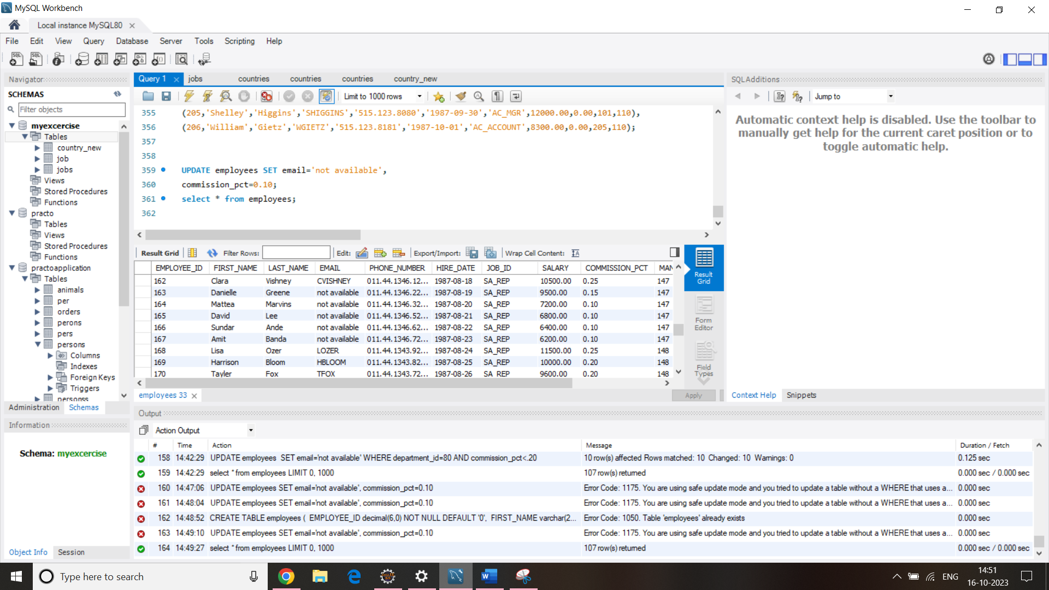

+-------------+-------------+-------------+----------+--------------------+------------+------------+----------+----------------+------------+---------------+

| EMPLOYEE_ID | FIRST_NAME | LAST_NAME | EMAIL | PHONE_NUMBER | HIRE_DATE | JOB_ID | SALARY | COMMISSION_PCT | MANAGER_ID | DEPARTMENT_ID |

+-------------+-------------+-------------+----------+--------------------+------------+------------+----------+----------------+------------+---------------+

| 100 | Steven | King | SKING | 515.123.4567 | 1987-06-17 | AD_PRES | 24000.00 | 0.00 | 0 | 90 |

| 101 | Neena | Kochhar | NKOCHHAR | 515.123.4568 | 1987-06-18 | AD_VP | 17000.00 | 0.00 | 100 | 90 |

| 102 | Lex | De Haan | LDEHAAN | 515.123.4569 | 1987-06-19 | AD_VP | 17000.00 | 0.00 | 100 | 90 |

| 103 | Alexander | Hunold | AHUNOLD | 590.423.4567 | 1987-06-20 | IT_PROG | 9000.00 | 0.00 | 102 | 60 |

| 104 | Bruce | Ernst | BERNST | 590.423.4568 | 1987-06-21 | IT_PROG | 6000.00 | 0.00 | 103 | 60 |

| 105 | David | Austin | DAUSTIN | 590.423.4569 | 1987-06-22 | IT_PROG | 4800.00 | 0.00 | 103 | 60 |

| 106 | Valli | Pataballa | VPATABAL | 590.423.4560 | 1987-06-23 | IT_PROG | 4800.00 | 0.00 | 103 | 60 |

| 107 | Diana | Lorentz | DLORENTZ | 590.423.5567 | 1987-06-24 | IT_PROG | 4200.00 | 0.00 | 103 | 60 |

| 108 | Nancy | Greenberg | NGREENBE | 515.124.4569 | 1987-06-25 | FI_MGR | 12000.00 | 0.00 | 101 | 100 |

| 109 | Daniel | Faviet | DFAVIET | 515.124.4169 | 1987-06-26 | FI_ACCOUNT | 9000.00 | 0.00 | 108 | 100 |

| 110 | John | Chen | JCHEN | 515.124.4269 | 1987-06-27 | FI_ACCOUNT | 8200.00 | 0.00 | 108 | 100 |

| 111 | Ismael | Sciarra | ISCIARRA | 515.124.4369 | 1987-06-28 | FI_ACCOUNT | 7700.00 | 0.00 | 108 | 100 |

| 112 | Jose Manuel | Urman | JMURMAN | 515.124.4469 | 1987-06-29 | FI_ACCOUNT | 7800.00 | 0.00 | 108 | 100 |

| 113 | Luis | Popp | LPOPP | 515.124.4567 | 1987-06-30 | FI_ACCOUNT | 6900.00 | 0.00 | 108 | 100 |

| 114 | Den | Raphaely | DRAPHEAL | 515.127.4561 | 1987-07-01 | PU_MAN | 11000.00 | 0.00 | 100 | 30 |

| 115 | Alexander | Khoo | AKHOO | 515.127.4562 | 1987-07-02 | PU_CLERK | 3100.00 | 0.00 | 114 | 30 |